First attempt

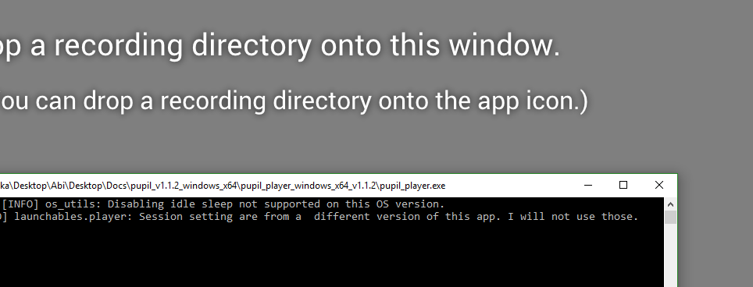

I ignore this and try the drag and drop anyway as closing the console kills the app.

Kills app

…. Dug into GitHub. And found conversation.

Found and downloaded the following as per @pointscontrol

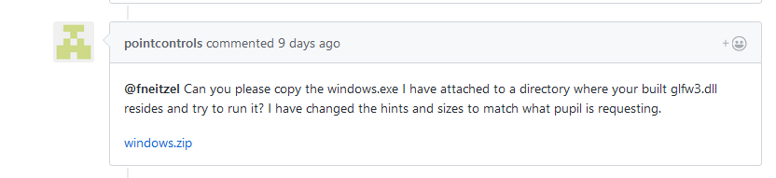

Ended here

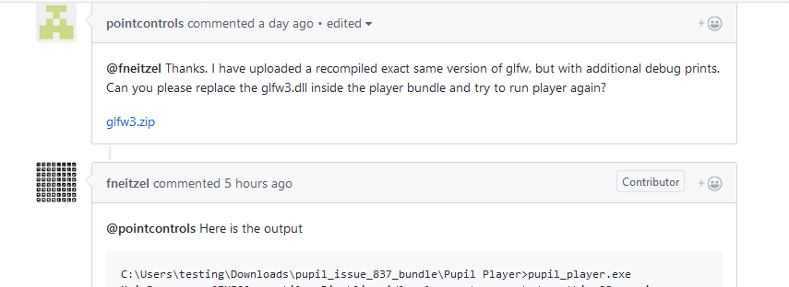

Downloaded glfw3.zip – and copied the dll in to the player folder as below

Attempted to open again

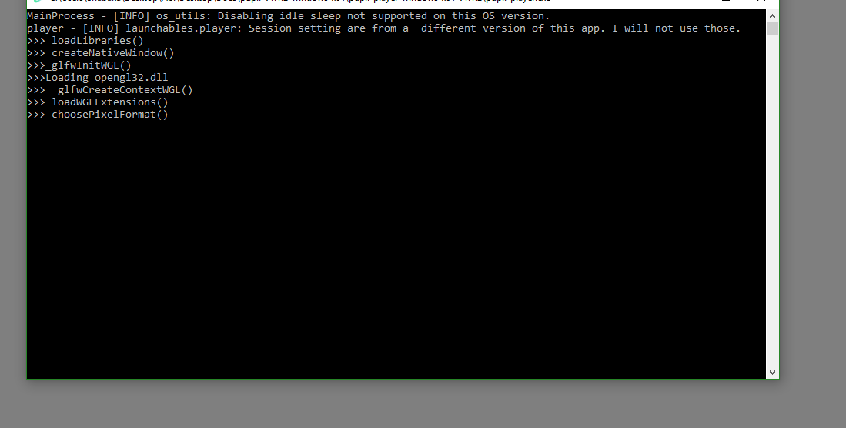

I recalled I has previously copied the glfw3 dll file into this folder – while rummaging around and the OpenGL compatibility had been mentioned – so I deleted it

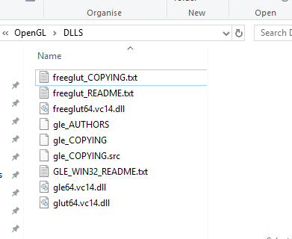

Nope! No change… Hmm…

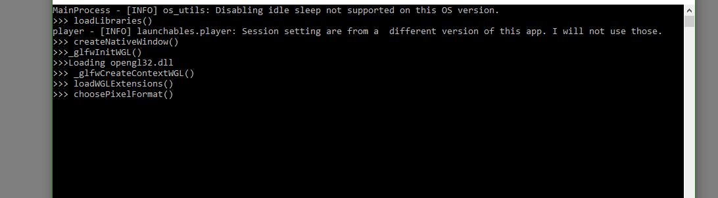

System Spec

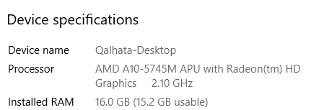

Anyway, I download the OpenGL update

