1. **VISIT COUNT**

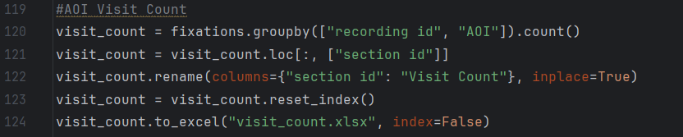

Here we added in the following code to see how many times an individual participant visited each defined AOI. The output for “visit_count.xlsx” has been attached separately.

1. **TIME TO FIRST CONTACT**

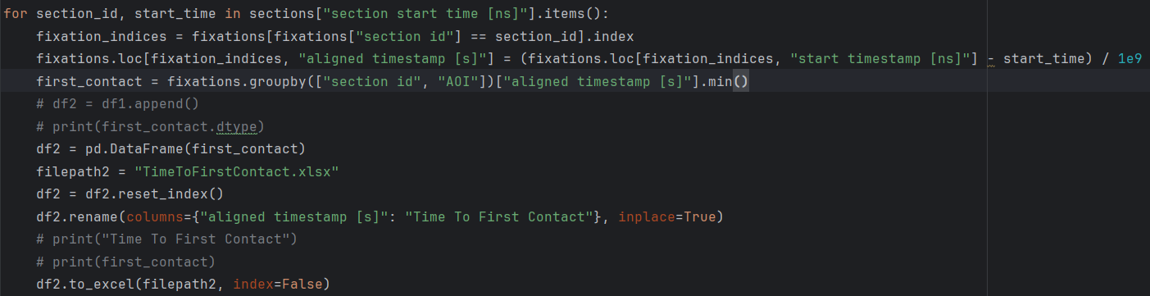

Here we expect to get the Time to First Contact on every AOI for each participant. Here we made the assumption that every recording ID had its own unique section ID and hence we used the section IDs instead of the recording ID. Please let us know if this assumption is correct. The output file is attached separately “TimeToFirstContact.xlsx”.

1. **DWELL TIME**

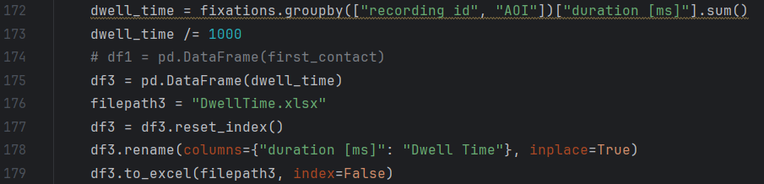

Here we hope to get how much time each participant has looked at each AOI respectively. Again I have attached the excel sheet separately and the file name is “DwellTime.xlsx”.

**PLEASE NOTE –** The code has been executed with the example AOIs given in the link - <https://docs.pupil-labs.com/alpha-lab/gaze-metrics-in-aois/> . We uncommented the predetermined AOIs and used that data.